Dear:

We want you back! On behalf of the Federal Managers Association, I am writing to urge you to renew your membership with FMA.

FMA continues to serve as the leading voice for managers and supervisors throughout the federal government. With membership encompassing more than 35 different agencies and departments, we represent a broad array of federal managers who recognize the importance of our mission – to advocate excellence in public service through effective management.

In addition to representing your interests before Congress and the Executive Branch, we offer you a complimentary subscription to our flagship publication, The Federal Manager, which includes timely articles on Association business, effective management tools that you can apply to your job and career, and helpful retirement advice as you make the transition into your golden years. You will also receive our bi-weekly electronic newsletter, the Washington Report, which provides advocacy progress updates on issues that affect you.

We at FMA recognize that your time and resources are precious commodities, and we thank you for having previously belonged to our Association. If you elect not to renew your membership, we would greatly appreciate an opportunity to understand why so that we may incorporate your feedback in seeking to better our services and benefits. Please take a moment to call at the FMA National Office at (703) 683-8700 to give your input.

Again, FMA strives to provide forceful, effective advocacy, valuable professional development, and money-saving benefits on insurance, legal consultation and financial planning, among other terrific discounts – all for the low rate of $125 a year for members-at-large, or half that ($63) for retired members. You also have the option if you are retired from federal service to become a Life Member at a one-time payment of $250.

We hope you will once again become part of the FMA family. If you have any questions or concerns, please do not hesitate to contact us. Thank you.

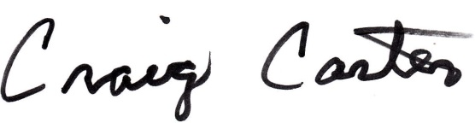
With warmest regards,

Craig Carter
National President

